
Software Engineering Lab
Silent Distress Reporting System (SDRS)

Raghav Sanoria – 23BCE0877
School of Computer Science and Engineering (SCOPE)

Table of Contents
Revision History
- Introduction
  - Purpose
  - Document Conventions
  - Intended Audience & Reading Suggestions
    - Intended Audience
    - Reading Suggestions
  - Product Scope
  - Functional Requirements
  - Non-Functional Requirements
  - References
- Requirements Modeling
  - Structural Requirement Modeling
    - Entity Relationship (ER) Diagram
      - Identified Entities and Attributes
      - Relationships and Cardinality
  - Functional Requirement Modeling
    - Context Flow Diagram (CFD)
      - External Entities
      - Data Flows
  - Behavioral Requirement Modeling
    - State Transition Diagram
      - Identified States
      - State Transitions and Events
- Object-Oriented Design
  - Use Case Model
    - Identified Actors
    - Major Use Cases
  - Class Diagram (Structural Design)
    - Identified Classes
    - Relationships Between Classes
  - Interaction Model
    - Sequence of Operations – Alert Trigger Scenario
  - Package Diagram
    - Identified Packages
  - Component Diagram
    - Major Components
  - Deployment Diagram
    - Deployment Environment

1. Introduction
1.1 Purpose
The purpose of this Software Requirements Specification (SRS) document is to define the functional and non-functional requirements of the Silent Distress Reporting System (SDRS). This document provides a comprehensive description of the system’s objectives, scope, operating environment, and constraints. It serves as a foundational reference for system designers, developers, testers, and stakeholders involved in the development and evaluation of the system.
The Silent Distress Reporting System is designed to enable individuals in unsafe or sensitive environments to request help discreetly without drawing attention. This document ensures a clear and common understanding of system behaviour, features, and quality attributes before implementation.

1.2 Document Conventions
This SRS document follows the IEEE Standard for Software Requirements Specification.
- Text Styles: Headings in bold, subheadings in Times New Roman.
- Diagrams: Represented using UML notations.
- Abbreviations: SDRS (Silent Distress Reporting System), UI (User Interface), DB (Database), GPS (Global Positioning System).

1.3 Intended Audience & Reading Suggestions
1.3.1 Intended Audience
This document is intended for the following audiences:
- Project Stakeholders / Reviewers
To understand the purpose, relevance, and overall functionality of the system.

- System Analysts and Designers
To analyse requirements and translate them into architectural and design models.

- Software Developers
To use the functional and non-functional requirements as guidelines during system implementation.

- Testers and Evaluators
To validate system behaviour against defined requirements.

1.4 Product Scope
The Silent Distress Reporting System (SDRS) is a safety-focused software application intended to provide a discreet mechanism for users to report distress in situations where overt help-seeking actions may be unsafe or impossible.
The system allows users to trigger emergency alerts through camouflaged interfaces such as fake forms, calculator-style inputs, or predefined interaction patterns. Once triggered, the system automatically shares essential information—such as location, time, and severity level—with trusted contacts or authorized responders.
The primary objectives of SDRS are:
- To enhance personal safety without attracting attention
- To ensure privacy, confidentiality, and secure communication
- To minimize response time during critical situations
The system is suitable for use in environments such as hostels, workplaces, public spaces, and institutions where personal safety is a concern.
Key Features in Scope:
- Discreet distress-trigger mechanisms
- Automatic alert generation with location and timestamp
- Role-based access for users, responders, and administrators

1.5 Functional Requirements
The system shall provide the following functional capabilities:
- User registration and secure authentication
- Configuration of trusted contacts and responders
- Silent triggering of distress alerts through disguised user interfaces
- Automatic capture of location, time, and alert severity
- Secure notification delivery to designated recipients
- Alert history logging for authorized access
- Administrative control for user and system management

1.6 Non- Functional Requirements
The system shall satisfy the following non-functional requirements:
- Security
All sensitive data must be encrypted during storage and transmission.

- Privacy
User identity and distress information must be accessible only to authorized parties.

- Reliability
The system must function accurately under emergency conditions with minimal failure.

- Usability
The user interface must be simple, intuitive, and non-suspicious in appearance.

- Performance
Alert notifications should be dispatched within a few seconds of activation.

1.7 References
- IEEE Std 830-1998, IEEE Recommended Practice for Software Requirements Specifications
- OWASP Foundation, Secure Application Design Guidelines

2. Requirements Modeling
This section describes the requirement modeling techniques used to analyse and represent the Silent Distress Reporting System (SDRS) from structural, functional, and behavioural perspectives. Requirement modeling helps in understanding the system requirements clearly before proceeding to detailed design and implementation.

2.1 Structural Requirement Modeling
Structural requirement modeling focuses on the static structure of the system, identifying data entities, their attributes, and the relationships between them.
2.1.1 Entity Relationship (ER) Diagram
The purpose of the Entity Relationship (ER) diagram is to represent the data structure of the Silent Distress Reporting System. It identifies the key entities involved in the system, their attributes, and the relationships among them. This diagram provides a clear understanding of how data is organized and stored within the system.
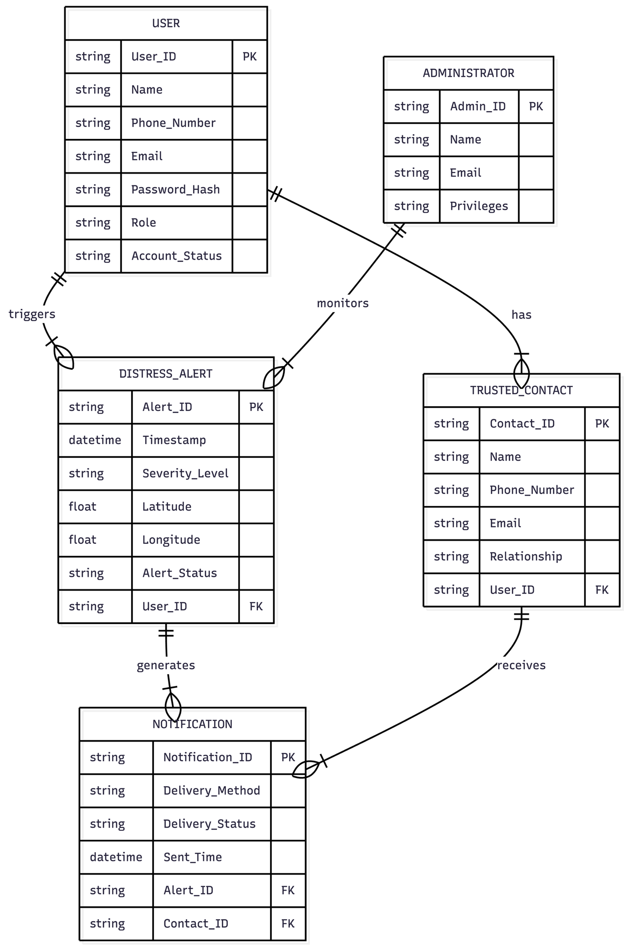
2.1.1.1 Identified Entities and Attributes
The following are the major entities identified in the Silent Distress Reporting System:
- User: Stores information related to registered users of the system.
- Distress Alert: Represents an emergency alert triggered by a user.
- Trusted Contact: Contains details of contacts who are notified during distress situations.
- Notification: Maintains records of alerts sent to trusted contacts.
- Administrator: Manages system configuration and monitoring.

2.1.1.2 Relationships and Cardinality

The relationships among the entities define how data elements interact within the system:
- A User can trigger multiple Distress Alerts (one-to-many).
- A User can have multiple Trusted Contacts (one-to-many).
- Each Distress Alert can generate multiple Notifications (one-to-many).
- A Notification is sent to one Trusted Contact.
- An Administrator can monitor multiple Distress Alerts.

2.2 Functional Requirement Modeling

Functional requirement modeling represents how the system interacts with external entities and defines the system boundaries.

2.2.1 Context Flow Diagram (CFD)

The Context Flow Diagram (CFD) illustrates the Silent Distress Reporting System as a single high-level process and shows its interaction with external entities. It helps in defining the system boundary and understanding the flow of information between the system and its environment.

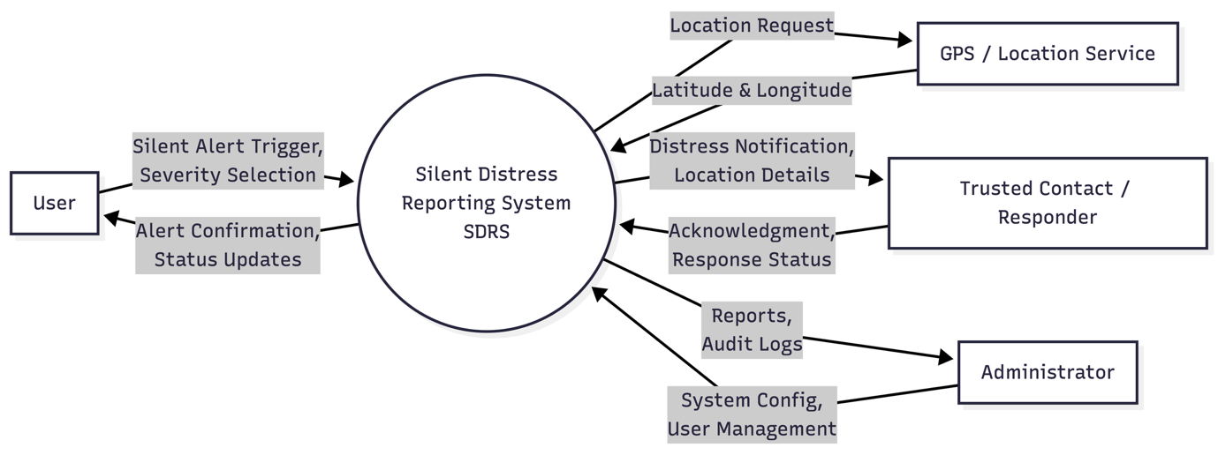

2.2.1.1 External Entities

The major external entities interacting with the system are:
- User: Initiates silent distress alerts and receives confirmation messages.
- Trusted Contact / Responder: Receives distress notifications and provides acknowledgments.
- Administrator: Oversees system operations and accesses alert reports.
- GPS / Location Service: Provides real-time location data for distress alerts.

2.2.1.2 Data Flows

The key data flows between the system and external entities include:
- Silent alert trigger from User to SDRS
- Location request and response between SDRS and GPS Service
- Distress notification from SDRS to Trusted Contacts
- Response acknowledgment from Trusted Contacts to SDRS
- System reports and logs from SDRS to Administrator

2.3 Behavioral Requirement Modeling

Behavioral requirement modeling captures the dynamic behavior of the system, focusing on how it responds to events over time.

2.3.1 State Transition Diagram

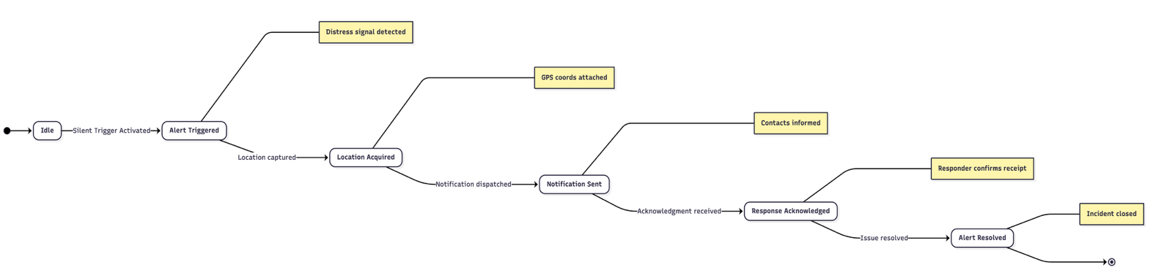
The purpose of the State Transition Diagram is to model the lifecycle of a distress alert in the Silent Distress Reporting System. It illustrates the different states an alert goes through and the events that cause transitions between these states.

2.3.1.1 Identified States

The main states identified in the system include:
- Idle
- Alert Triggered
- Location Acquired
- Notification Sent
- Response Acknowledged
- Alert Resolved

2.3.1.2 State Transitions and Events

State transitions occur based on specific events:
- Silent trigger activates transition from Idle to Alert Triggered
- Location capture moves the alert to Location Acquired
- Notification dispatch leads to Notification Sent
- Responder acknowledgment transitions the system to Response Acknowledged
- Issue resolution completes the process in Alert Resolved

3. Object-Oriented Design
This section describes the object-oriented design of the Silent Distress Reporting System (SDRS).
3.1 Use Case Model
The Use Case Model represents the functional behaviour of the Silent Distress Reporting System from the perspective of external actors interacting with the system. It defines the system boundary and illustrates how users and external entities communicate with the system.
3.1.1 Identified Actors
The following actors interact with the system:
- User
- Trusted Contact / Responder
- Administrator
- GPS Service
3.1.2 Major Use Cases
The major use cases supported by SDRS include:
- User Registration
- User Login
- Configure Trusted Contacts
- Trigger Silent Distress Alert
- Capture Location
- Send Notification
- Acknowledge Alert
- View Alert Logs
- Manage Users

The following diagram illustrates the interaction between actors and the system.

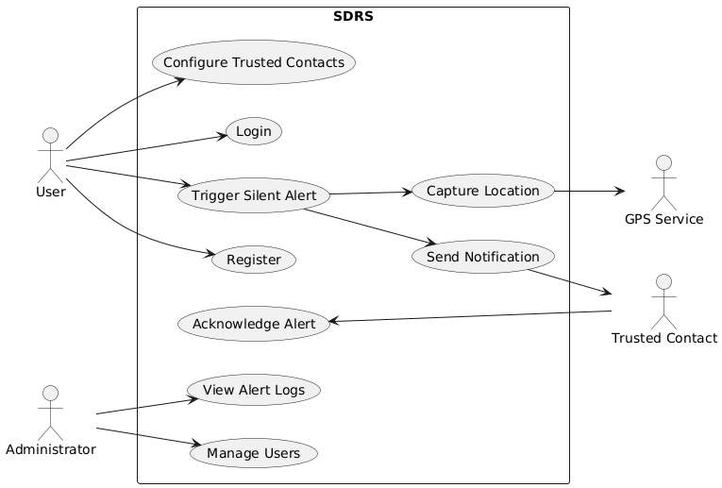

3.2 Class Diagram (Structural Design)
The Class Diagram represents the static structure of the Silent Distress Reporting System. It defines system classes, their attributes, operations (methods), and relationships between them. The diagram reflects object-oriented principles such as encapsulation and modular design.
3.2.1 Identified Classes
The major classes in the system are:
- User
- Administrator
- DistressAlert
- TrustedContact
- Notification
3.2.2 Relationships Between Classes
- A User can have multiple TrustedContact instances (one-to-many relationship).
- A User can trigger multiple DistressAlert instances (one-to-many relationship).
- A DistressAlert can generate multiple Notification instances (one-to-many relationship).
- Each Notification is associated with one TrustedContact.
- An Administrator monitors multiple DistressAlert instances.

The following diagram represents the static structure of SDRS.

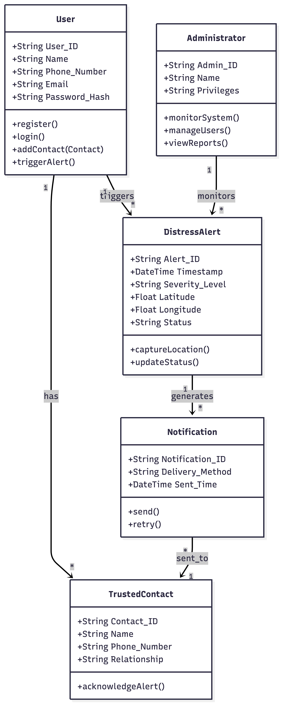
3.3 Interaction Model
The Interaction Model describes how system objects communicate dynamically during runtime. It is represented using a Sequence Diagram that captures the flow of messages during a distress alert scenario.
3.3.1 Sequence of Operations – Alert Trigger Scenario
The sequence of operations during a distress alert is as follows:
- The User activates the silent trigger through the SDRS application interface.
- The SDRS Application Interface requests the current geographical coordinates from the GPS Service.
- The GPS Service returns the latitude and longitude values to the application.
- The SDRS Application Interface creates a new alert record in the Database.
- The Database generates and returns a unique Alert ID.
- The SDRS Application Interface dispatches the alert to the Notification Service.
- The Notification Service sends the distress notification to the designated Trusted Contact (Responder).
- The Trusted Contact acknowledges receipt of the alert.
- The SDRS Application Interface updates the alert status in the Database to "Acknowledged".
- The system provides silent feedback confirmation to the User, ensuring discretion.
This interaction ensures secure alert creation, reliable notification delivery, proper status tracking, and discreet user confirmation.
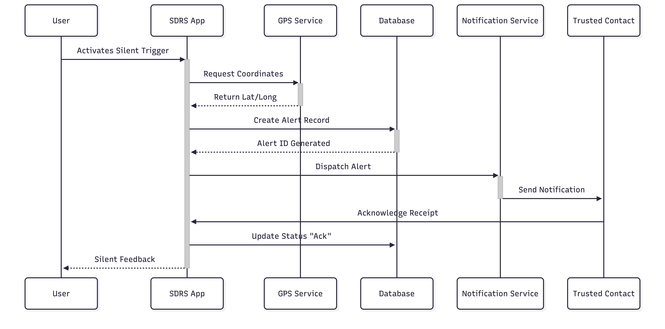

3.4 Package Diagram
The Package Diagram organizes the system into logical modules based on functionality. It improves modularity, scalability, and maintainability by separating system concerns.
3.4.1 Identified Packages
The SDRS is divided into the following packages:
- User Management Package: Handles registration and authentication.
- Alert Management Package: Manages alert generation and status tracking.
- Contact Management Package: Stores and manages trusted contacts.
- Administration Package: Provides monitoring and user management capabilities.
- External Services Package: Handles integration with GPS and messaging systems.

The following diagram shows the modular organization of SDRS.

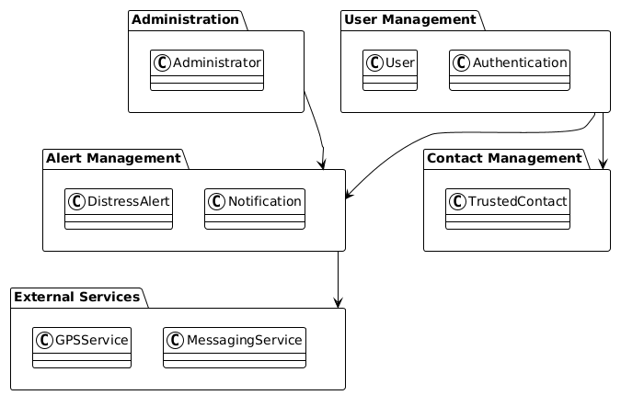

3.5 Component Diagram
The Component Diagram represents the high-level architecture of the system. It illustrates the major software components and their dependencies.
3.5.1 Major Components
The system consists of the following components:
- User Interface
- Authentication Module
- Alert Processing Module
- Notification Module
- Database
- GPS Service
- Messaging Gateway
The following diagram illustrates the architectural components of the system.

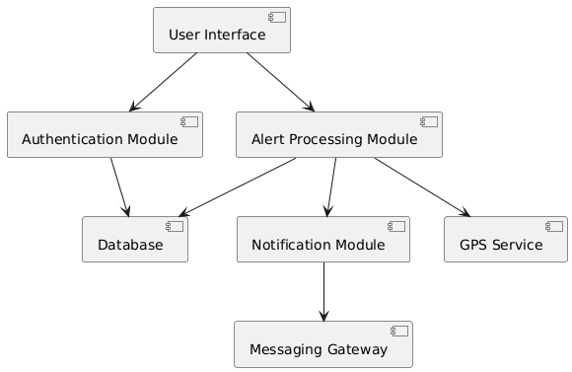

3.6 Deployment Diagram
The Deployment Diagram illustrates the physical architecture of the system, showing how software components are deployed across hardware nodes and external systems.
3.6.1 Deployment Environment
The Silent Distress Reporting System is deployed across:
- User Device (Mobile Application)
- Application Server
- Database Server
- External Services

The following diagram represents the physical deployment architecture.

